**Tron Game**

Written and Implemented By

ISROILBEK JAMOLOV (DXFV5Y)

Course: Programming Technology Faculty of Informatics

Eötvös Loránd University Date: 12 DEC 2023

# Contents

**Task description.…………………………………………………………………………………… 3 Task analysis.……………………………………………………………………………………… 3 The structure of the program (UML diagram)…………………………………………………. 4 Implementations of algorithms………………………………………………………………….. 7 Connections between the events and their handlers………………………………………. 8 Testing…………………………………………………………………………………………...…. 9**

**Task description**

The task is to create a two-player game inspired by the movie “Tron”. Each player controls a motor that leaves a light trail on the dipslay of the board. The game ends when a player collides with a trail or the game boundary. The game includes a leaderboard that displays the top 10 scores. Also, the game can be restarted using menu item. In addition, there are 10 levels where they are responsible for the modifications of board size, speed and seld-collision. In other words, the game screen will shrink by levels, and the speed of the bikes will increase, as well as after 6’s level the seld-collision be turned off.

# Task analysis

The game can be broken down into several components, each with its own functionality:

* Game: Represents the overall state of the game.
* Level: Represents a level in the game.
* Motorcycle: Represents a motorcycle in the game.
* Player: Represents a player in the game.
* Trail: Represents a trail left by a motorcycle.
* GameController: Controls the game.
* InputHandler: Handles user input.
* MainWindow: The main window of the game.
* Board: Represents the game board.
* Database: Handles database operationa.

# The structure of the program (UML diagram)

**ALL PACKAGES**

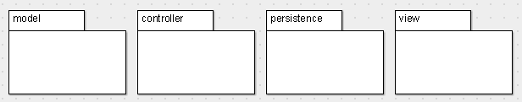

**PACKAGES WITH OWN CLASSES**

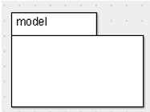

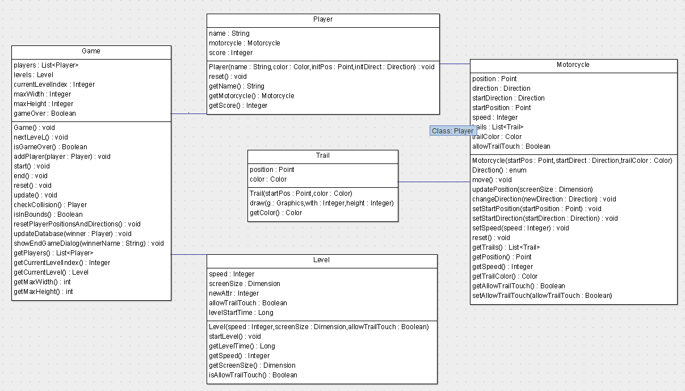

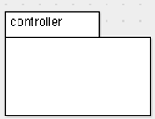

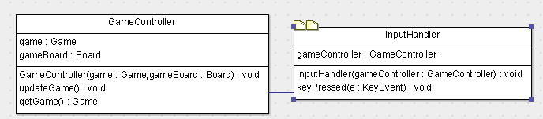

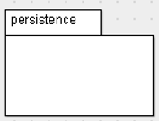

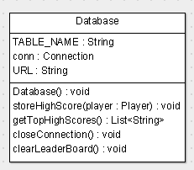

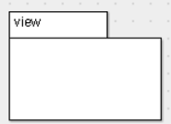

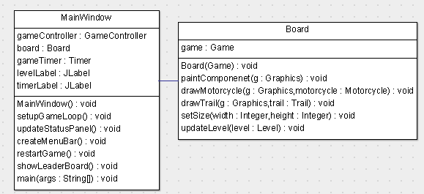

**RELATIONSHIP OF PACKAGES**

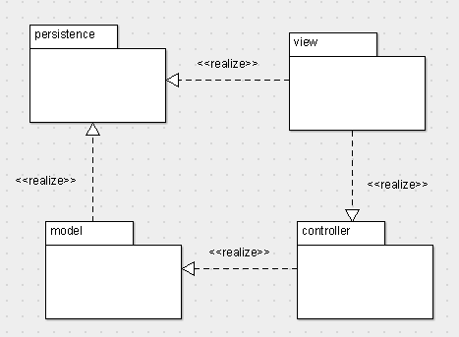

**Implementation of algorithms**

### 1 Game Progression

The game progression is handled by the nextLevel method in the Game class. This method increases the current level index, adjusts the maximum width and height of the game area, and updates the speed of the motorcycles. If the current level index exceeds the number of levels, it resets to the first level.

### 2 Collision Detection

Collision detection is handled by the checkCollision method in the Game class. This method checks if a motorcycle’s position is out of bounds or if it collides with another player’s trail. If a collision is detected, it returns the player who lost.

### 3 Game Update

The game state is updated in the update method in the Game class. This method moves each motorcycle and checks for collisions. If a collision is detected, it ends the game.

### 4 User Input Handling

User input is handled by the keyPressed method in the InputHandler class. This method listens for key presses and changes the direction of the motorcycles accordingly.

### 5 Game Rendering

The game rendering is handled by the paintComponent method in the Board class. This method draws the motorcycles and trails on the game board.

### 6 High Score Management

High score management is handled by the Database class. This class provides methods to store high scores, retrieve the top high scores, and clear the leaderboard.

These algorithms work together to create a complete, functioning game. 😊

# Connections between the events and their handlers

### 1 User Input Events

User input events are handled by the InputHandler class. When a user presses a key, the keyPressed method in the InputHandler class is triggered. This method changes the direction of the motorcycles based on the key pressed by the user.

### 2 Game Update Events

Game update events are handled by the GameController class. The GameController class sets up a timer that triggers an event every millisecond. When this event is triggered, the updateGame method in the GameController class is called. This method updates the game state and repaints the game board.

### 3 Game Over Events

Game over events are handled by the Game class. When a collision is detected, the end method in the Game class is called. This method sets the game over state to true and stops the game timer.

### 4 Game Restart Events

Game restart events are handled by the MainWindow class. When the user selects the “Restart Game” menu item, the restartGame method in the MainWindow class is called. This method resets the game state, starts the game, and restarts the game timer.

### 5 Leaderboard Display Events

Leaderboard display events are handled by the MainWindow class. When the user selects the “Show Leaderboard” menu item, the showLeaderboard method in the MainWindow class is called. This method retrieves the top high scores from the database and displays them in a dialog.

# Testing

### 1. User doesn’t write name

**Test Case**: Attempt to start the game without entering a name for a player.

**Expected Result**: The game should not start and the user should be prompted again to enter a name.

### 2. User doesn’t choose color

**Test Case**: Attempt to start the game without choosing a color for a player.

**Expected Result**: The player will be given black color by default.

### 3. Incrementing existing name

**Test Case**: Win a game with a player name that already exists in the leaderboard.

**Expected Result**: The score for that player name in the leaderboard should be incremented by one, if that player exists, otherwise a new player will be added with score 1.

### 4. Leaderboard size

**Test Case**: Add more than 10 players to the leaderboard.

**Expected Result**: Only the top 10 players (based on score), in a descending order, should be displayed on the leaderboard.

### 5. Self-touch before 7th level

**Test Case**: Make a player’s motorcycle touch its own trail before the 7th level.

**Expected Result**: The player should lose the game.

### 6. Timer after each level

**Test Case**: Advance to the next level.

**Expected Result**: The timer should reset to 0 at the start of each level.

### 7. Level Progression

**Test Case**: Complete a level and observe the changes in the next level.

**Expected Result**: The speed of the motorcycles should increase and the size of the game area should decrease with each level, and after level 7 the self-touching will not bring to collision.

### 8. Collision with Other Player’s Trail

**Test Case**: Make a player’s motorcycle touch the other player’s trail.

**Expected Result**: The player should lose the game.

### 9. Collision with Game Boundary

**Test Case**: Make a player’s motorcycle touch the game boundary.

**Expected Result**: The player should lose the game.

### 10. Restart Game

**Test Case**: Restart the game after a player loses.

**Expected Result**: The game state should reset, the game should start again, and the game timer , players’ properties, except name and the color, should be reset as well.

### 11. Show Leaderboard

**Test Case**: Select the “Show Leaderboard” menu item.

**Expected Result**: The top high scores from the database should be displayed in a dialog. The leaderboard can be seen in the list of menu items.

### 12. Motorcycle Movement

**Test Case**: Press a key to change the direction of a motorcycle.

**Expected Result**: The motorcycle should move in the direction set by the user every second.  
Valid keyboard are “W,A,S,D” and directional keyboards, pressing the rest of the keyboards do not effect the flow of the game.